# Port of Shanghai

Port in China

The **Port of Shanghai** ([Chinese](https://en.wikipedia.org/wiki/Chinese_language" \o "Chinese language): 上海港; [pinyin](https://en.wikipedia.org/wiki/Pinyin" \o "Pinyin): *Shànghǎi Gǎng ; [Wu](https://en.wikipedia.org/wiki/Wu_Chinese" \o "Wu Chinese); Zånhae Kån*), located in the vicinity of [Shanghai](https://en.wikipedia.org/wiki/Shanghai" \o "Shanghai), comprises a deep-sea port and a river port.

[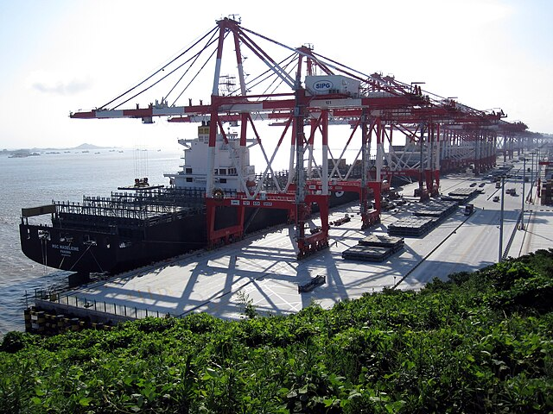](https://en.wikipedia.org/wiki/File:Yangshan-Port-Balanced.jpg)Shanghai is the world's busiest [container port](https://en.wikipedia.org/wiki/Container_port" \o "Container port).[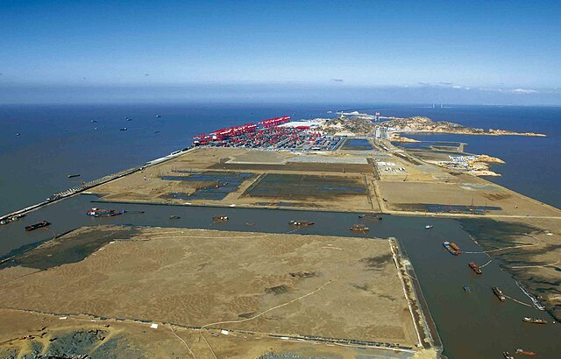](https://en.wikipedia.org/wiki/File:Yangshan_Deepwater_Port.jpg)Yangshan Deepwater Port under construction

The main port enterprise in Shanghai, the Shanghai International Port Group (SIPG), was established during the reconstitution of the Shanghai Port Authority. Companies such as the Shanghai Port Container Co. and Waigaoqiao Bonded Zone Port Co. were involved in port of Shanghai.

In 2010, Shanghai port overtook the [Port of Singapore](https://en.wikipedia.org/wiki/Port_of_Singapore) to become the [world's busiest container port](https://en.wikipedia.org/wiki/List_of_world's_busiest_container_ports" \o "List of world's busiest container ports). Shanghai's port handled 29.05 million [TEU](https://en.wikipedia.org/wiki/Twenty-foot_equivalent_unit), whereas Singapore's was a half million TEU behind. Shanghai handled 43.3 million TEU in 2019.

Shanghai is one of only four port-cities in the world to be categorised as a large-port Megacity, due to its high volumes of port traffic and large urban population.

## Geography

The Port of Shanghai faces the [East China Sea](https://en.wikipedia.org/wiki/East_China_Sea) to the east and [Hangzhou Bay](https://en.wikipedia.org/wiki/Hangzhou_Bay" \o "Hangzhou Bay) to the south. It includes the confluences of the [Yangtze River](https://en.wikipedia.org/wiki/Yangtze_River" \o "Yangtze River), [Huangpu River](https://en.wikipedia.org/wiki/Huangpu_River" \o "Huangpu River) (which enters the Yangtze River) and [Qiantang River](https://en.wikipedia.org/wiki/Qiantang_River" \o "Qiantang River).

## Administration

The Port of Shanghai is managed by [Shanghai International Port](https://en.wikipedia.org/wiki/Shanghai_International_Port_(Group)" \o "Shanghai International Port (Group)), which superseded the Shanghai Port Authority in 2003. Shanghai International Port Company Limited is a public listed company, of which the Shanghai Municipal Government owns 44% of the outstanding shares.

## History

*See also: [History of Shanghai](https://en.wikipedia.org/wiki/History_of_Shanghai" \o "History of Shanghai)*

In 1842, Shanghai became a [treaty port](https://en.wikipedia.org/wiki/Treaty_ports" \o "Treaty ports), thus developing into an international commercial city. By the early 20th century, it was the largest city and the largest port in East Asia. In 1949, with the [Communist](https://en.wikipedia.org/wiki/Communist_Party_of_China" \o "Communist Party of China) takeover in Shanghai, overseas trade was cut dramatically. The economic policy of the People's Republic had a crippling effect on Shanghai's infrastructure and capital development.

[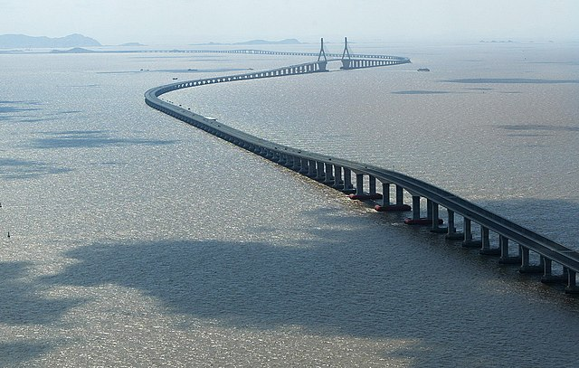](https://en.wikipedia.org/wiki/File:Donghai_Bridge.jpg)

[Donghai Bridge](https://en.wikipedia.org/wiki/Donghai_Bridge)

In 1991, the central government allowed Shanghai to initiate economic reform. Since then, the port has developed at a rapid pace. By 2005, the [Yangshan](https://en.wikipedia.org/wiki/Yangshan_Port" \o "Yangshan Port) deep-water port had been built on the Yangshan islands, a group of islands in [Hangzhou Bay](https://en.wikipedia.org/wiki/Hangzhou_Bay" \o "Hangzhou Bay) linked to Shanghai by the [Donghai Bridge](https://en.wikipedia.org/wiki/Donghai_Bridge" \o "Donghai Bridge). This development allowed the port to overcome shallow water conditions in its current location and to rival another deep-water port, the nearby [Ningbo](https://en.wikipedia.org/wiki/Ningbo" \o "Ningbo)-[Zhoushan](https://en.wikipedia.org/wiki/Zhoushan) port.

The port is part of the [21st Century Maritime Silk Road](https://en.wikipedia.org/wiki/21st_Century_Maritime_Silk_Road) that runs from the Chinese coast to [Singapore](https://en.wikipedia.org/wiki/Singapore" \o "Singapore), towards the southern tip of [India](https://en.wikipedia.org/wiki/India" \o "India) to [Mombasa](https://en.wikipedia.org/wiki/Mombasa" \o "Mombasa), from there through the Red Sea via the [Suez Canal](https://en.wikipedia.org/wiki/Suez_Canal" \o "Suez Canal) to the Mediterranean, there to the Upper Adriatic region to the northern Italian hub of [Trieste](https://en.wikipedia.org/wiki/Trieste" \o "Trieste) with its connections to [Central Europe](https://en.wikipedia.org/wiki/Central_Europe) and the [North Sea](https://en.wikipedia.org/wiki/North_Sea).

## Harbour zones

The port of Shanghai includes three major working zones:

* [Yangshan Deep Water Port](https://en.wikipedia.org/wiki/Yangshan_Port)
* [Huangpu River](https://en.wikipedia.org/wiki/Huangpu_River)
* [Yangtze River](https://en.wikipedia.org/wiki/Yangtze_River)